*LAB # 02*

CREATIONAL DESIGN PATTERNS: SINGLETON PATTERN

# *OBJECTIVE:*

*To understand the Creational Design Patterns: Singleton Pattern.*

* *Create a Singleton class and its object of your selected scenario****.***

***SINGLETON PATTERN:***

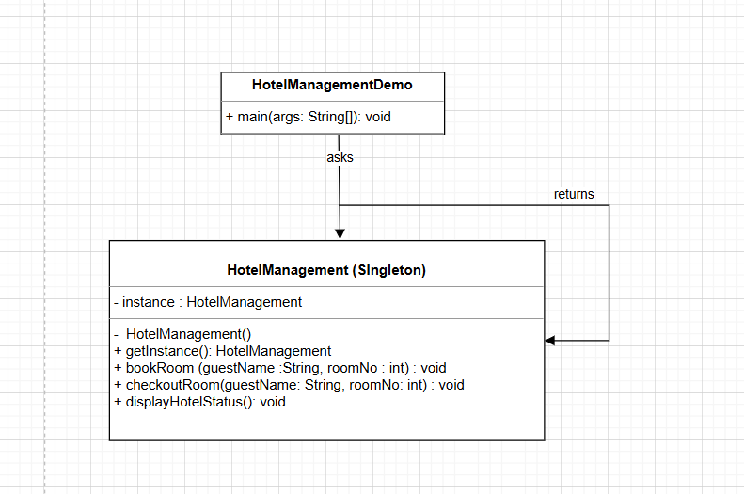

***JAVA CODE:***

### ***Step 1***

***Create a Singleton Class: HotelManagement.java***

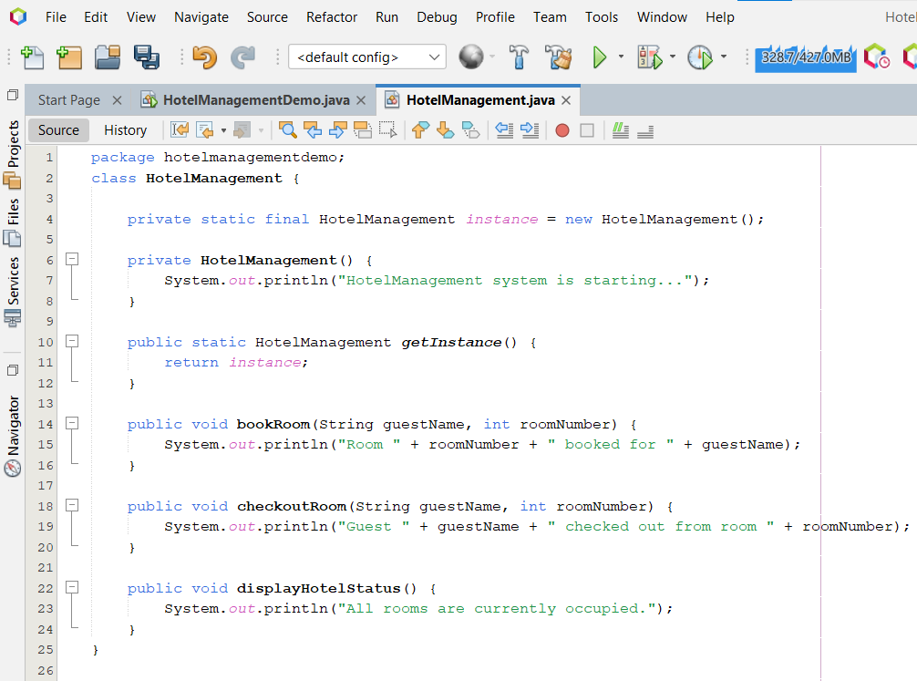

***Step 2***

***Get the only object from the singleton class: HotelManagementDemo.java***

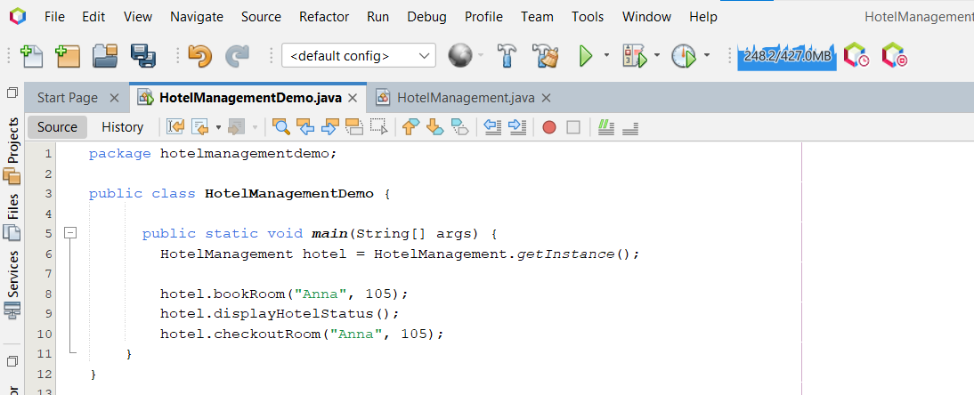

***OUTPUT:***

